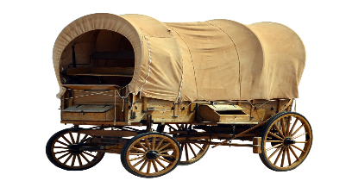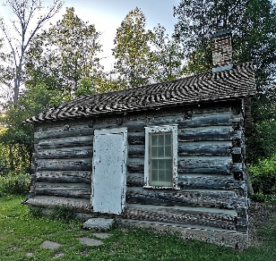
Frazier Farmstead Presents
Summer Reading Program
“Little House on the Prairie”
By Laura Ingalls Wilder
Starting July 7th or 9^{th.} Two separate sessions, Tuesdays and Thursdays, from 11:30-1:30 for six weeks.
Keeping with Oregon State social distancing rules, this program will mainly be held outside or in the carriage house.
Open to Ages 7-12. Limited to ten students per session.
Registration fee: $15.00 per student (to pay for a copy of the book and supplies)
Sponsored by Frazier Farmstead Museum. Leaders for the series are Karen Hendricks, Jacque Fox, and Laurie Hackney (retired teachers from the M-F School District).
Students are encouraged to bring a sack lunch.
__________________________________________________________________________________________
Registration Form for Summer Reading Program (Website: www.frazierfarmsteadmuseum.org)
Name __________________________
Email __________________________
Phone Number __________________
“I will abide by the rules of the program and understand that inappropriate behavior will not be tolerated.”
Student signature ______________________
Parent signature _______________________
Please enclose cash or check made out to Frazier Farmstead for $15.00 by June 26, 2020. Mail registration to Frazier Farmstead, PO Box 764 Milton Freewater, OR 97862. You may also put the registration form in the mail slot in the front door of the Farmstead Museum house.
I prefer : (1st come first serve basis)
_____ Session # 1: Tuesday @ 11:30am-1:30pm
_____ Session # 2: Thursday @ 11:30am-1:30pm
You will be notified by email or phone by July 3rd as to which session you will be assigned to.
Little House Literature Study
Calendar of Events

Each session will start with a reading of one Chapter from the book. Participants may bring a sack lunch to eat while we read and discuss the Chapter. (The Milton-Freewater School District does provide free sack lunches for children from ages 1 to 18. Check their website for scheduled pick up times at different sites.)
Week One: July 7 or 8th
Introductions of teachers and Program
Pass out Books: Read Chapter one Aloud.
Begin Making Journals
Pass out Wagons to be completed at home and brought back to be shared the last day of the Program.
Assign Chapters to be read at home(Chap 2 through 5)
Assign Journal Prompts
Week 2: July 14th or 16th
Read aloud Chapter six, share journal entries
Complete covers for Journals
Make Rag Dolls/play pioneer games we have both boy and girl rag doll patterns.
Assign Chapters 7 -10 to be read at home.
Assign Journal prompt
Week 3: July 21st or 23rd
Read aloud Chapter 11, share journal entries
Discuss Native American Culture and its significance in the History of settling the west.
Make a log cabin at the site of the McCoy cabin (on site at Frazier Farmstead
Assign journal prompt
Assign Chapters 12 -15 to be read at home.
Week 4: July 28th or 30th
Read Aloud Chapter 16, share journal entries
Learn about Native American Culture
Make Native American Teepee, play Native American Games
Assign Chapters 17 through 20 to be read at home.
Assign Journal prompt

Week 5: August 4th or 6th
To be Announced (we are hoping to take a field trip)
Assign Chapters 21 through 26 to be read at home.
^{Assign Journal prompt.}
^{Week 6 August 11th only}
^{Celebration Day:}
^{Share completed wagons}
Make and consume Food the Ingalls Family might have eaten
Play Games from the time Period.
^{Say Good byes for now!}

